**15.BLOOD BANK MANAGEMENT SYSTEM**

**USE CASE DIAGRAM**:

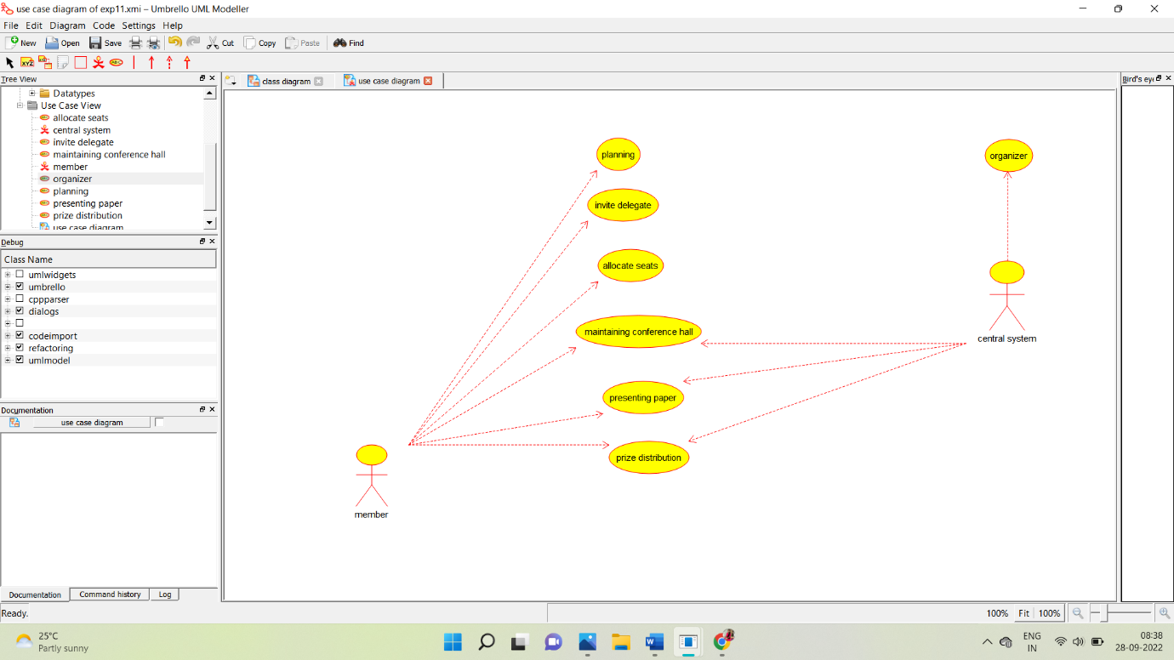

**CLASS DIAGRAM:**

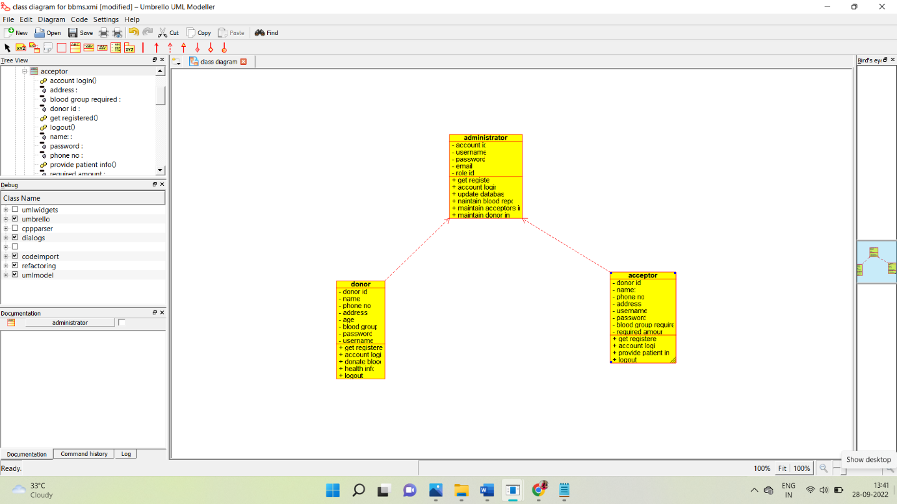

**ACTIVITY DIAGRAM:**

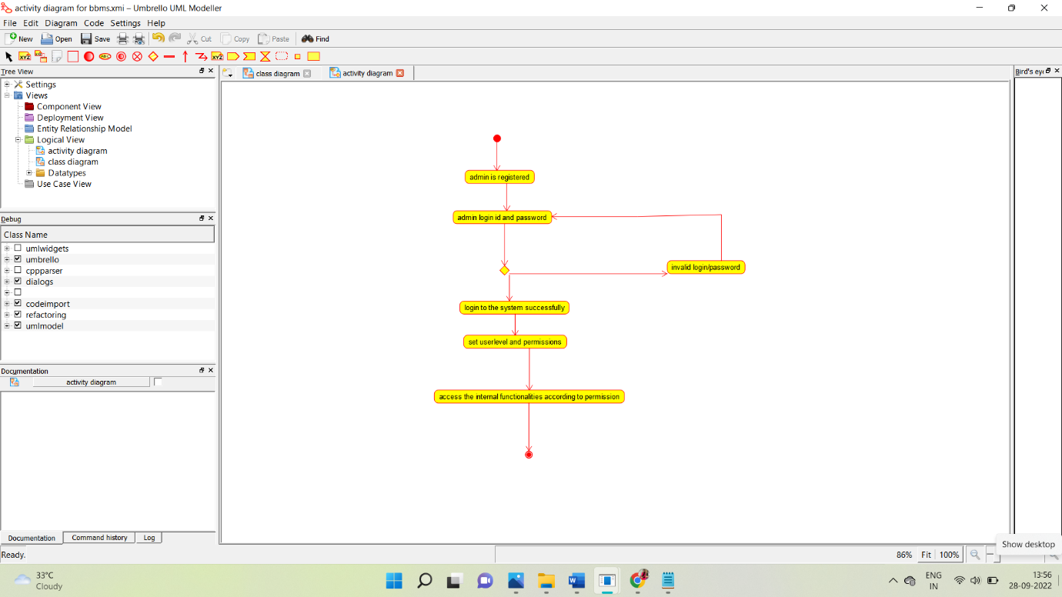

**SEQUENCE DIAGRAM:**

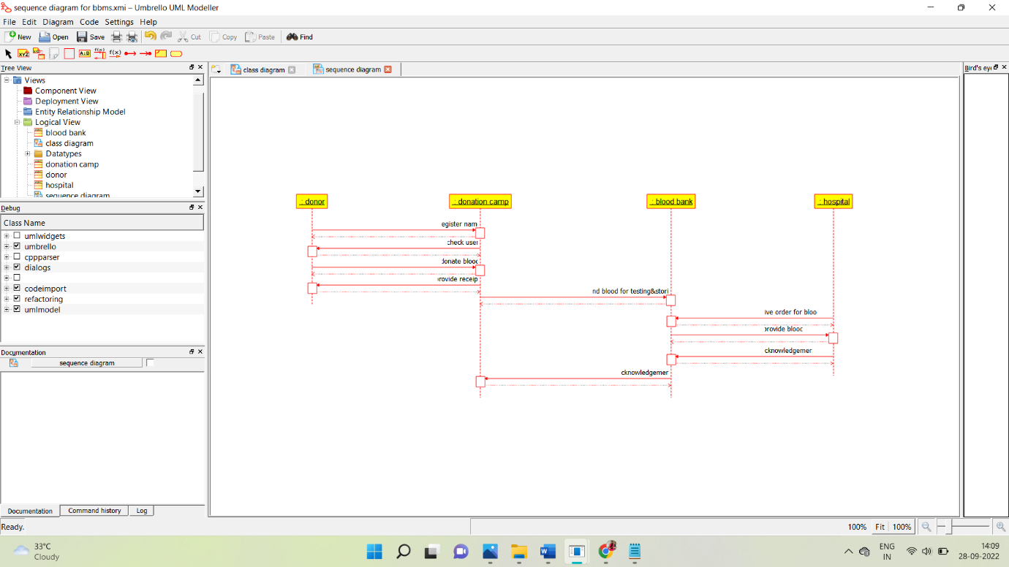

**COLLABORATION DIAGRAM:**

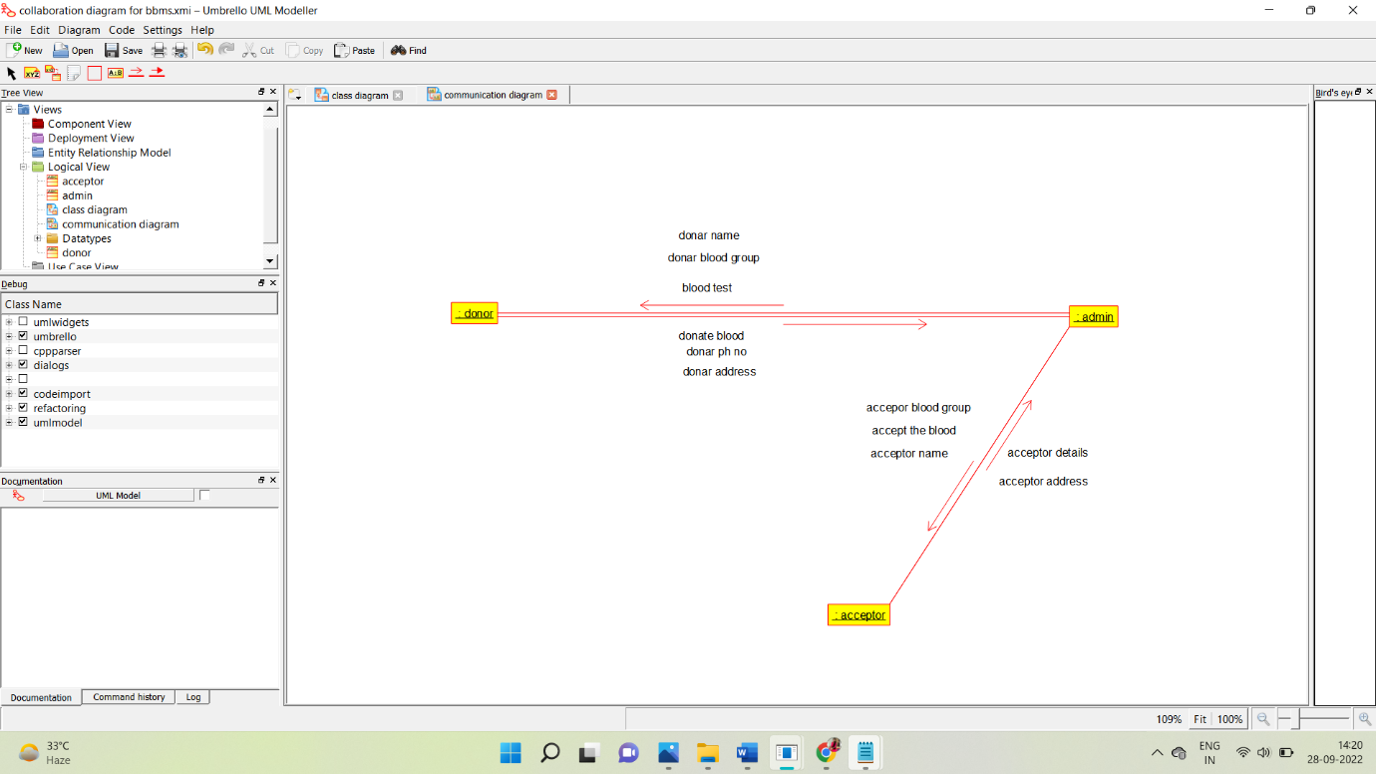

**STATE CHART DIAGRAM:**

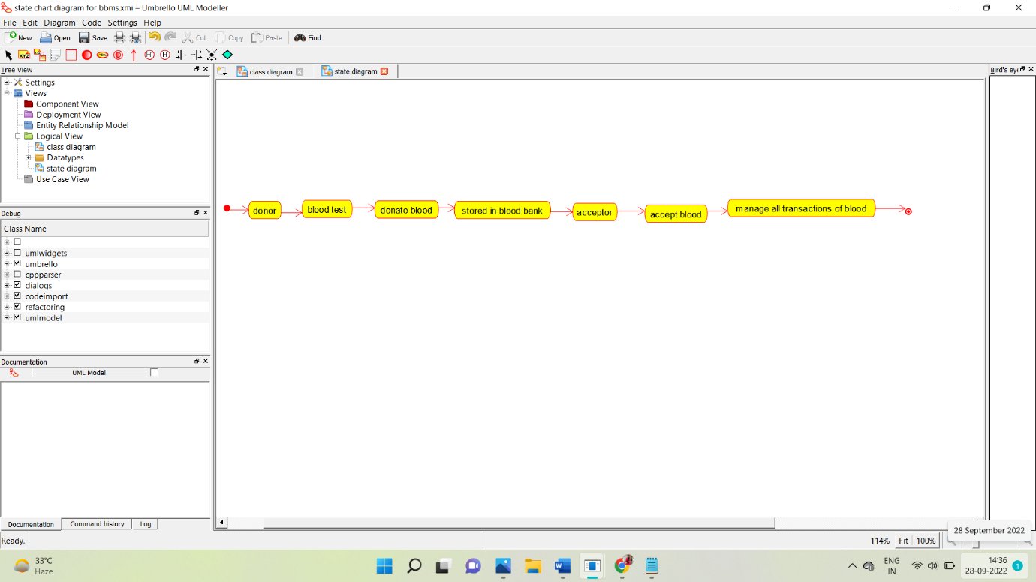

**COMPONENT DIAGRAM:**

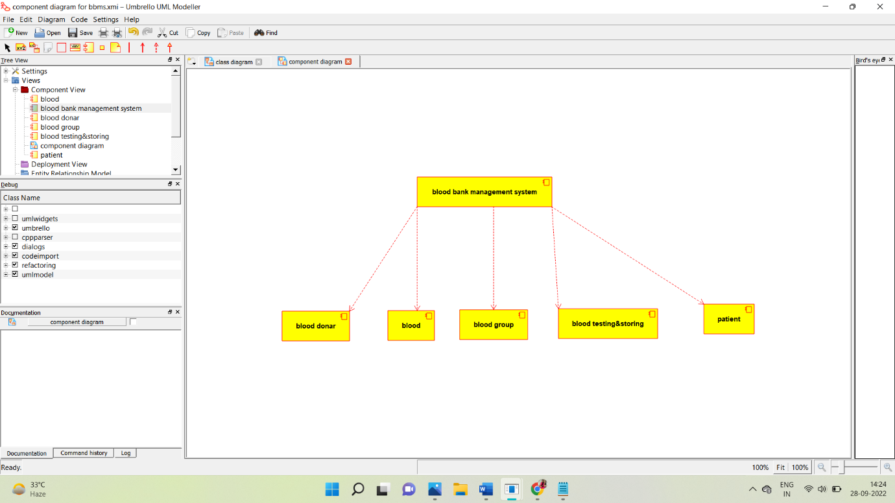

**DEPLOYMENT DIAGRAM:**

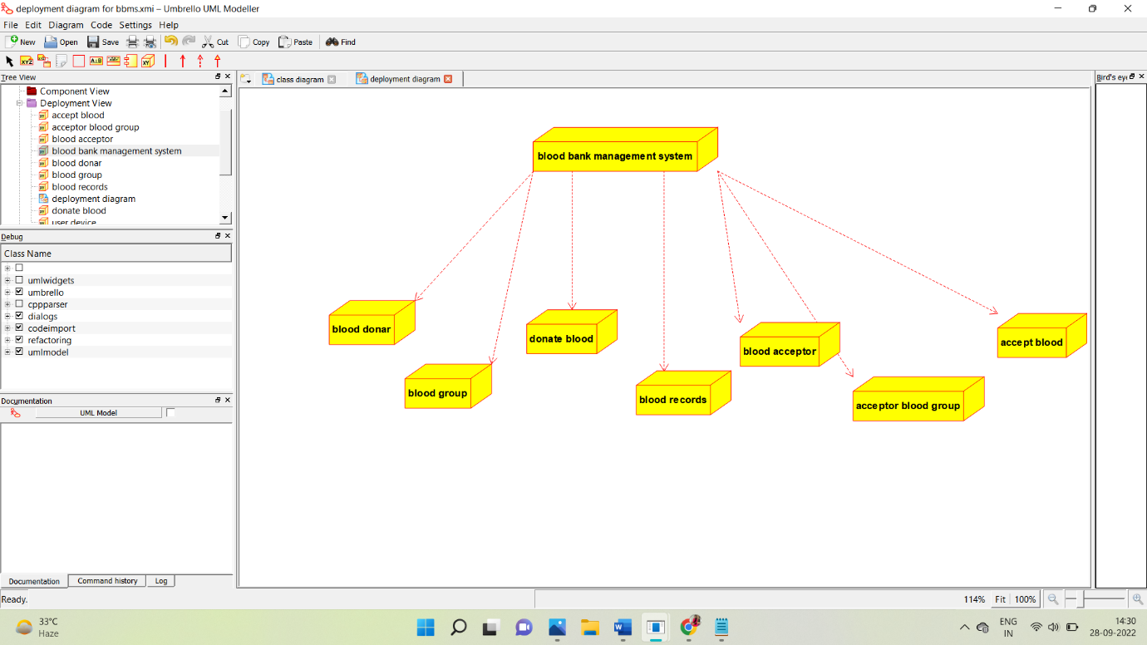

**PROGRAM:**

**\* Class administrator**

**\*/**

**public class administrator {**

**//**

**// Fields**

**//**

**private void account_id;**

**private void username;**

**private void password;**

**private void email;**

**private void role_id;**

**//**

**// Constructors**

**//**

**public administrator () { };**

**//**

**// Methods**

**//**

**//**

**// Accessor methods**

**//**

**/\*\***

**\* Set the value of account_id**

**\* @param newVar the new value of account_id**

**\*/**

**private void setAccount_id (void newVar) {**

**account_id = newVar;**

**}**

**/\*\***

**\* Get the value of account_id**

**\* @return the value of account_id**

**\*/**

**private void getAccount_id () {**

**return account_id;**

**}**

**/\*\***

**\* Set the value of username**

**\* @param newVar the new value of username**

**\*/**

**private void setUsername (void newVar) {**

**username = newVar;**

**}**

**/\*\***

**\* Get the value of username**

**\* @return the value of username**

**\*/**

**private void getUsername () {**

**return username;**

**}**

**/\*\***

**\* Set the value of password**

**\* @param newVar the new value of password**

**\*/**

**private void setPassword (void newVar) {**

**password = newVar;**

**}**

**/\*\***

**\* Get the value of password**

**\* @return the value of password**

**\*/**

**private void getPassword () {**

**return password;**

**}**

**/\*\***

**\* Set the value of email**

**\* @param newVar the new value of email**

**\*/**

**private void setEmail (void newVar) {**

**email = newVar;**

**}**

**/\*\***

**\* Get the value of email**

**\* @return the value of email**

**\*/**

**private void getEmail () {**

**return email;**

**}**

**/\*\***

**\* Set the value of role_id**

**\* @param newVar the new value of role_id**

**\*/**

**private void setRole_id (void newVar) {**

**role_id = newVar;**

**}**

**/\*\***

**\* Get the value of role_id**

**\* @return the value of role_id**

**\*/**

**private void getRole_id () {**

**return role_id;**

**}**

**//**

**// Other methods**

**//**

**/\*\***

**\*/**

**public void get_register()**

**{**

**}**

**/\*\***

**\*/**

**public void account_login_()**

**{**

**}**

**/\*\***

**\*/**

**public void update_database()**

**{**

**}**

**/\*\***

**\*/**

**public void naintain_blood_report()**

**{**

**}**

**/\*\***

**\*/**

**public void maintain_acceptors_info()**

**{**

**}**

**/\*\***

**\*/**

**public void maintain_donor_info()**

**{**

**}**

**\*\***

**\* Class donor**

**\*/**

**public class donor {**

**//**

**// Fields**

**//**

**private void donor_id;**

**private void name;**

**private void phone_no;**

**private void address;**

**private void age;**

**private void blood_group;**

**private void password;**

**private void username;**

**//**

**// Constructors**

**//**

**public donor () { };**

**//**

**// Methods**

**//**

**//**

**// Accessor methods**

**//**

**/\*\***

**\* Set the value of donor_id**

**\* @param newVar the new value of donor_id**

**\*/**

**private void setDonor_id (void newVar) {**

**donor_id = newVar;**

**}**

**/\*\***

**\* Get the value of donor_id**

**\* @return the value of donor_id**

**\*/**

**private void getDonor_id () {**

**return donor_id;**

**}**

**/\*\***

**\* Set the value of name**

**\* @param newVar the new value of name**

**\*/**

**private void setName (void newVar) {**

**name = newVar;**

**}**

**/\*\***

**\* Get the value of name**

**\* @return the value of name**

**\*/**

**private void getName () {**

**return name;**

**}**

**/\*\***

**\* Set the value of phone_no**

**\* @param newVar the new value of phone_no**

**\*/**

**private void setPhone_no (void newVar) {**

**phone_no = newVar;**

**}**

**/\*\***

**\* Get the value of phone_no**

**\* @return the value of phone_no**

**\*/**

**private void getPhone_no () {**

**return phone_no;**

**}**

**/\*\***

**\* Set the value of address**

**\* @param newVar the new value of address**

**\*/**

**private void setAddress (void newVar) {**

**address = newVar;**

**}**

**/\*\***

**\* Get the value of address**

**\* @return the value of address**

**\*/**

**private void getAddress () {**

**return address;**

**}**

**/\*\***

**\* Set the value of age**

**\* @param newVar the new value of age**

**\*/**

**private void setAge (void newVar) {**

**age = newVar;**

**}**

**/\*\***

**\* Get the value of age**

**\* @return the value of age**

**\*/**

**private void getAge () {**

**return age;**

**}**

**/\*\***

**\* Set the value of blood_group**

**\* @param newVar the new value of blood_group**

**\*/**

**private void setBlood_group (void newVar) {**

**blood_group = newVar;**

**}**

**/\*\***

**\* Get the value of blood_group**

**\* @return the value of blood_group**

**\*/**

**private void getBlood_group () {**

**return blood_group;**

**}**

**/\*\***

**\* Set the value of password**

**\* @param newVar the new value of password**

**\*/**

**private void setPassword (void newVar) {**

**password = newVar;**

**}**

**/\*\***

**\* Get the value of password**

**\* @return the value of password**

**\*/**

**private void getPassword () {**

**return password;**

**}**

**/\*\***

**\* Set the value of username**

**\* @param newVar the new value of username**

**\*/**

**private void setUsername (void newVar) {**

**username = newVar;**

**}**

**/\*\***

**\* Get the value of username**

**\* @return the value of username**

**\*/**

**private void getUsername () {**

**return username;**

**}**

**//**

**// Other methods**

**//**

**/\*\***

**\*/**

**public void get_registered()**

**{**

**}**

**/\*\***

**\*/**

**public void account_login()**

**{**

**}**

**/\*\***

**\*/**

**public void donate_blood()**

**{**

**}**

**/\*\***

**\*/**

**public void health_info()**

**{**

**}**

**/\*\***

**\*/**

**public void logout()**

**{**

**}**

**}**

**/\*\***

**\* Class acceptor**

**\*/**

**public class acceptor {**

**//**

**// Fields**

**//**

**private void donor_id;**

**private void name_;**

**private void phone_no;**

**private void address;**

**private void username;**

**private void password;**

**private void blood_group_required;**

**private void required_amount;**

**//**

**// Constructors**

**//**

**public acceptor () { };**

**//**

**// Methods**

**//**

**//**

**// Accessor methods**

**//**

**/\*\***

**\* Set the value of donor_id**

**\* @param newVar the new value of donor_id**

**\*/**

**private void setDonor_id (void newVar) {**

**donor_id = newVar;**

**}**

**/\*\***

**\* Get the value of donor_id**

**\* @return the value of donor_id**

**\*/**

**private void getDonor_id () {**

**return donor_id;**

**}**

**/\*\***

**\* Set the value of name_**

**\* @param newVar the new value of name_**

**\*/**

**private void setName_ (void newVar) {**

**name_ = newVar;**

**}**

**/\*\***

**\* Get the value of name_**

**\* @return the value of name_**

**\*/**

**private void getName_ () {**

**return name_;**

**}**

**/\*\***

**\* Set the value of phone_no**

**\* @param newVar the new value of phone_no**

**\*/**

**private void setPhone_no (void newVar) {**

**phone_no = newVar;**

**}**

**/\*\***

**\* Get the value of phone_no**

**\* @return the value of phone_no**

**\*/**

**private void getPhone_no () {**

**return phone_no;**

**}**

**/\*\***

**\* Set the value of address**

**\* @param newVar the new value of address**

**\*/**

**private void setAddress (void newVar) {**

**address = newVar;**

**}**

**/\*\***

**\* Get the value of address**

**\* @return the value of address**

**\*/**

**private void getAddress () {**

**return address;**

**}**

**/\*\***

**\* Set the value of username**

**\* @param newVar the new value of username**

**\*/**

**private void setUsername (void newVar) {**

**username = newVar;**

**}**

**/\*\***

**\* Get the value of username**

**\* @return the value of username**

**\*/**

**private void getUsername () {**

**return username;**

**}**

**/\*\***

**\* Set the value of password**

**\* @param newVar the new value of password**

**\*/**

**private void setPassword (void newVar) {**

**password = newVar;**

**}**

**/\*\***

**\* Get the value of password**

**\* @return the value of password**

**\*/**

**private void getPassword () {**

**return password;**

**}**

**/\*\***

**\* Set the value of blood_group_required**

**\* @param newVar the new value of blood_group_required**

**\*/**

**private void setBlood_group_required (void newVar) {**

**blood_group_required = newVar;**

**}**

**/\*\***

**\* Get the value of blood_group_required**

**\* @return the value of blood_group_required**

**\*/**

**private void getBlood_group_required () {**

**return blood_group_required;**

**}**

**/\*\***

**\* Set the value of required_amount**

**\* @param newVar the new value of required_amount**

**\*/**

**private void setRequired_amount (void newVar) {**

**required_amount = newVar;**

**}**

**/\*\***

**\* Get the value of required_amount**

**\* @return the value of required_amount**

**\*/**

**private void getRequired_amount () {**

**return required_amount;**

**}**

**//**

**// Other methods**

**//**

**/\*\***

**\*/**

**public void get_registered()**

**{**

**}**

**/\*\***

**\*/**

**public void account_login()**

**{**

**}**

**/\*\***

**\*/**

**public void provide_patient_info()**

**{**

**}**

**/\*\***

**\*/**

**public void logout()**

**{**

**}**

**}**